**MIDDLETON CHENEY FOOTBALL CLUB**

**ANNUAL GENERAL MEETING**

**1978**

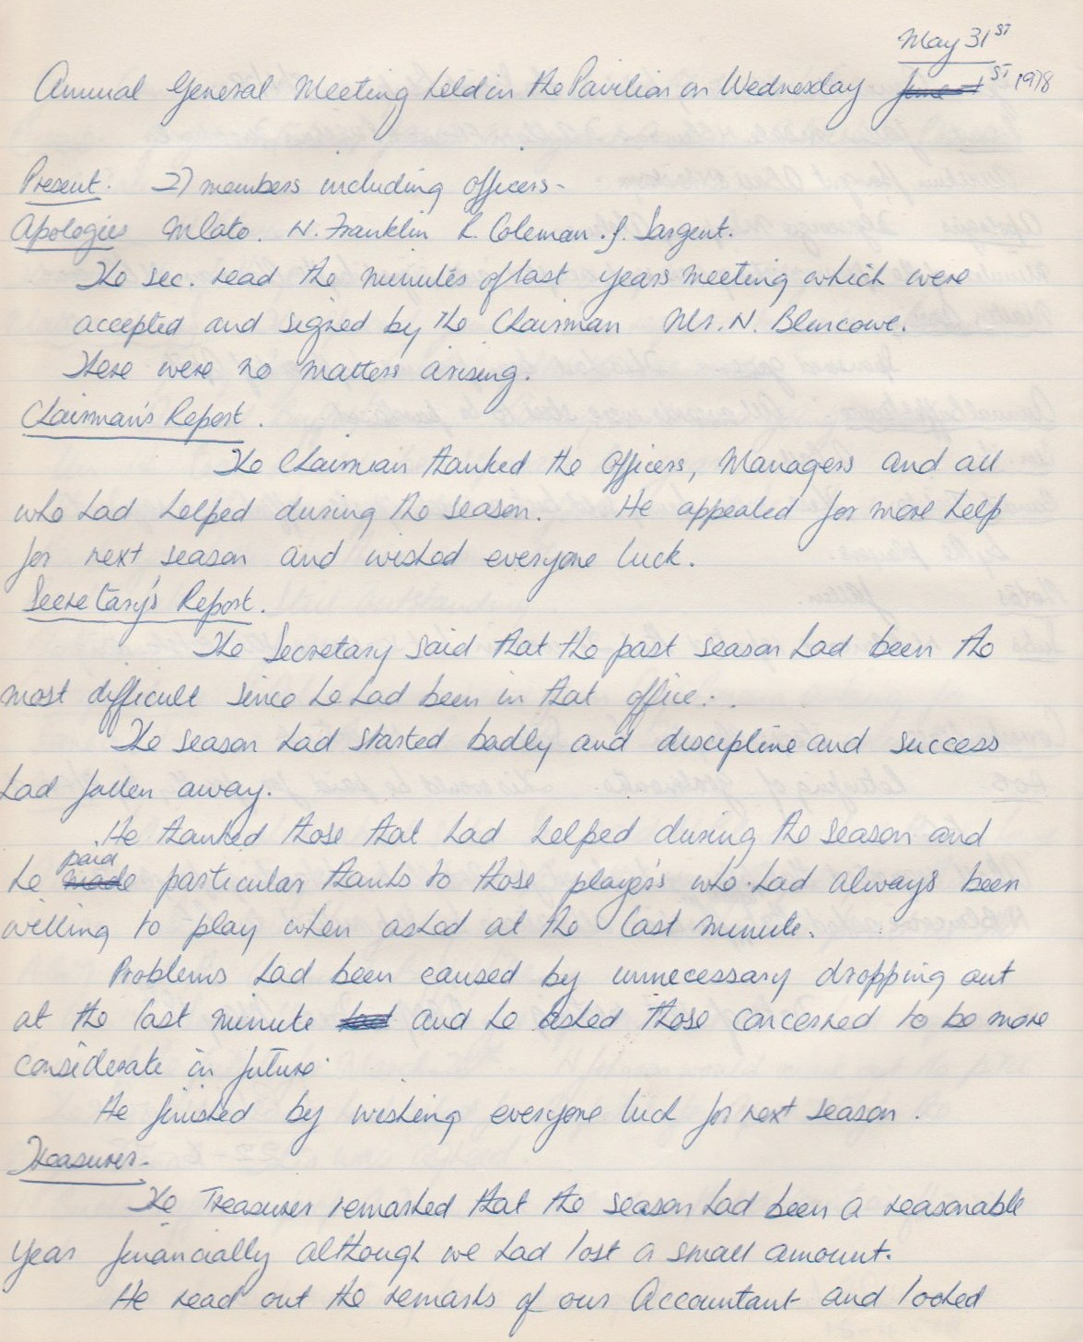

**Continued**

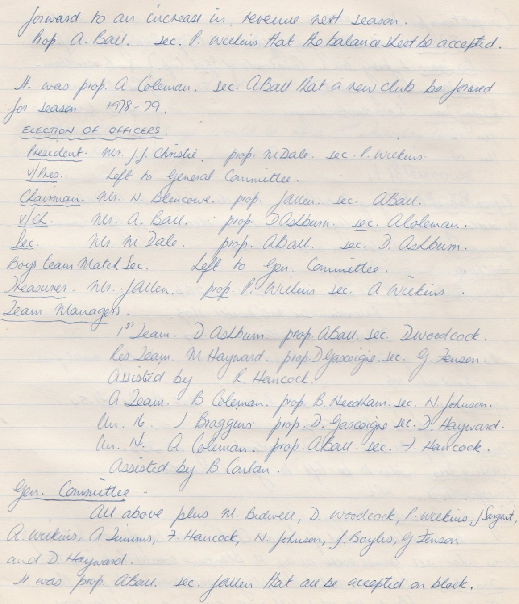

**Continued**

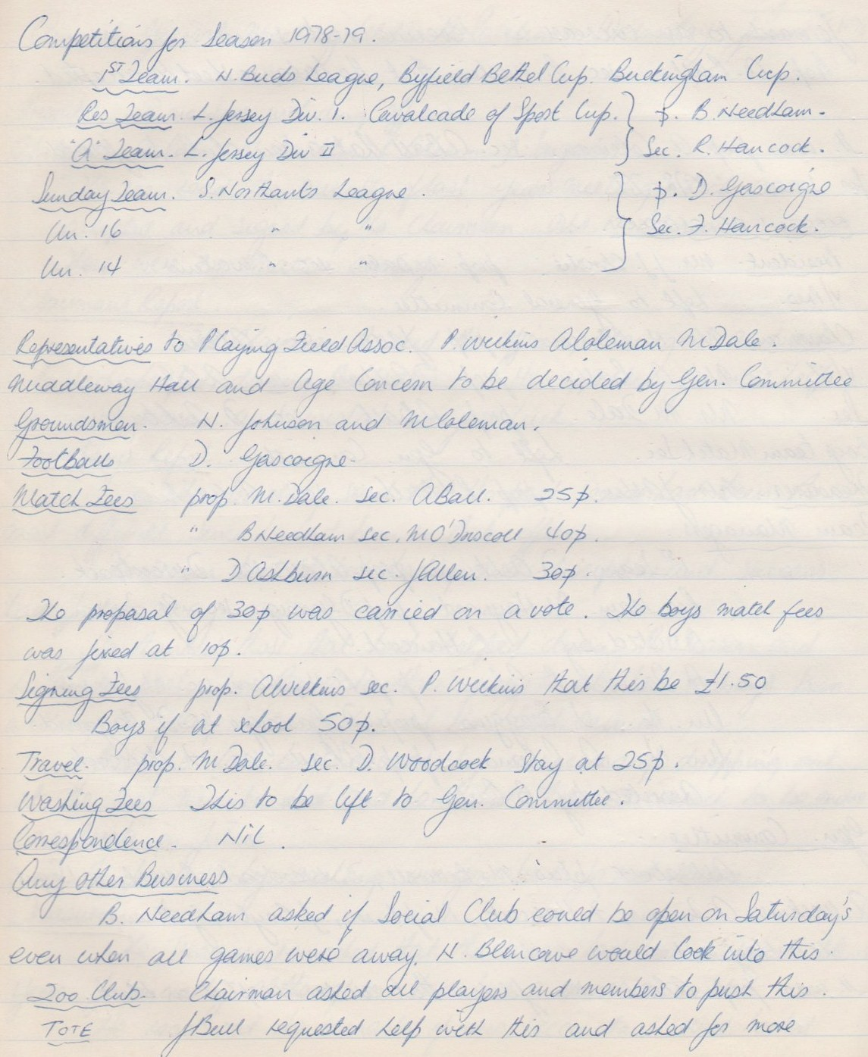

**Continued**

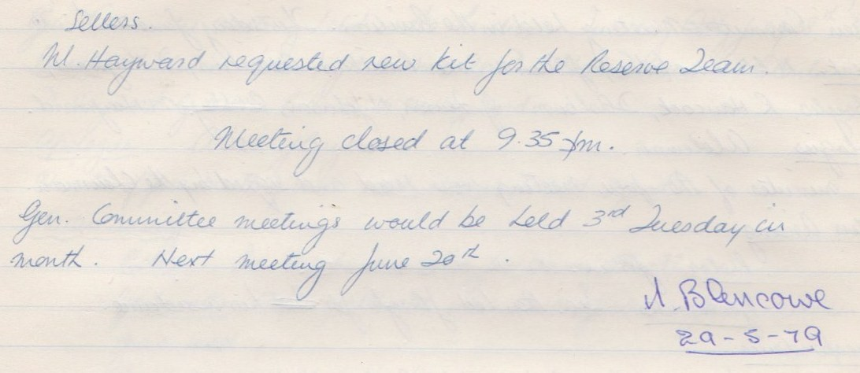

**General Committee Meeting**

**June 22nd 1978**

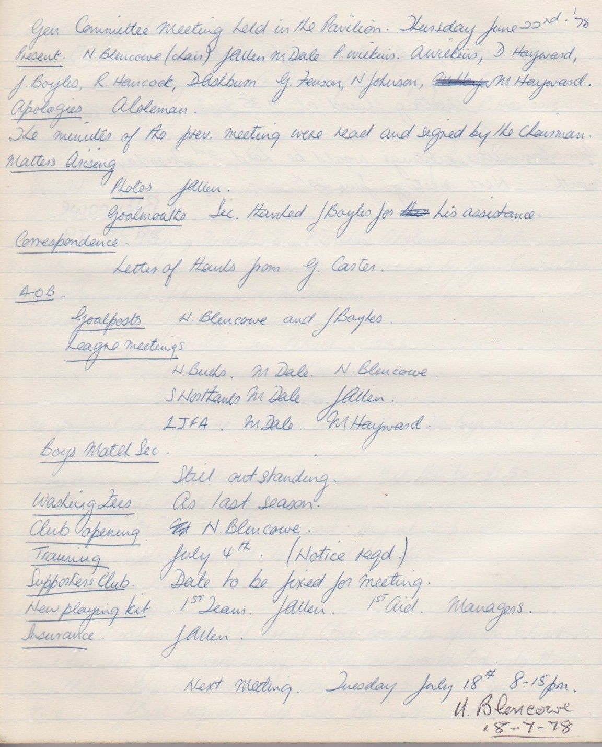

**General Committee Meeting**

**July 18th 1978**

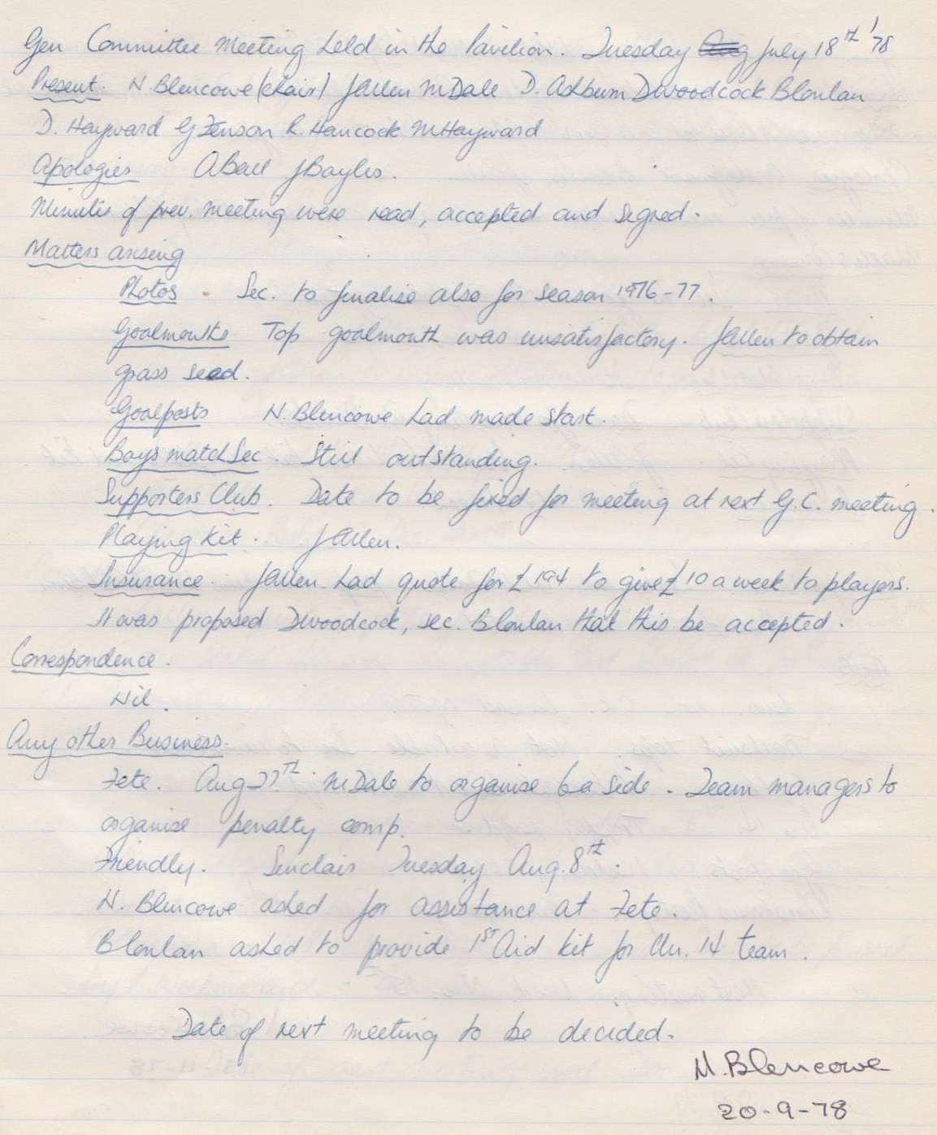

**General Committee Meeting**

**September 20th 1978**

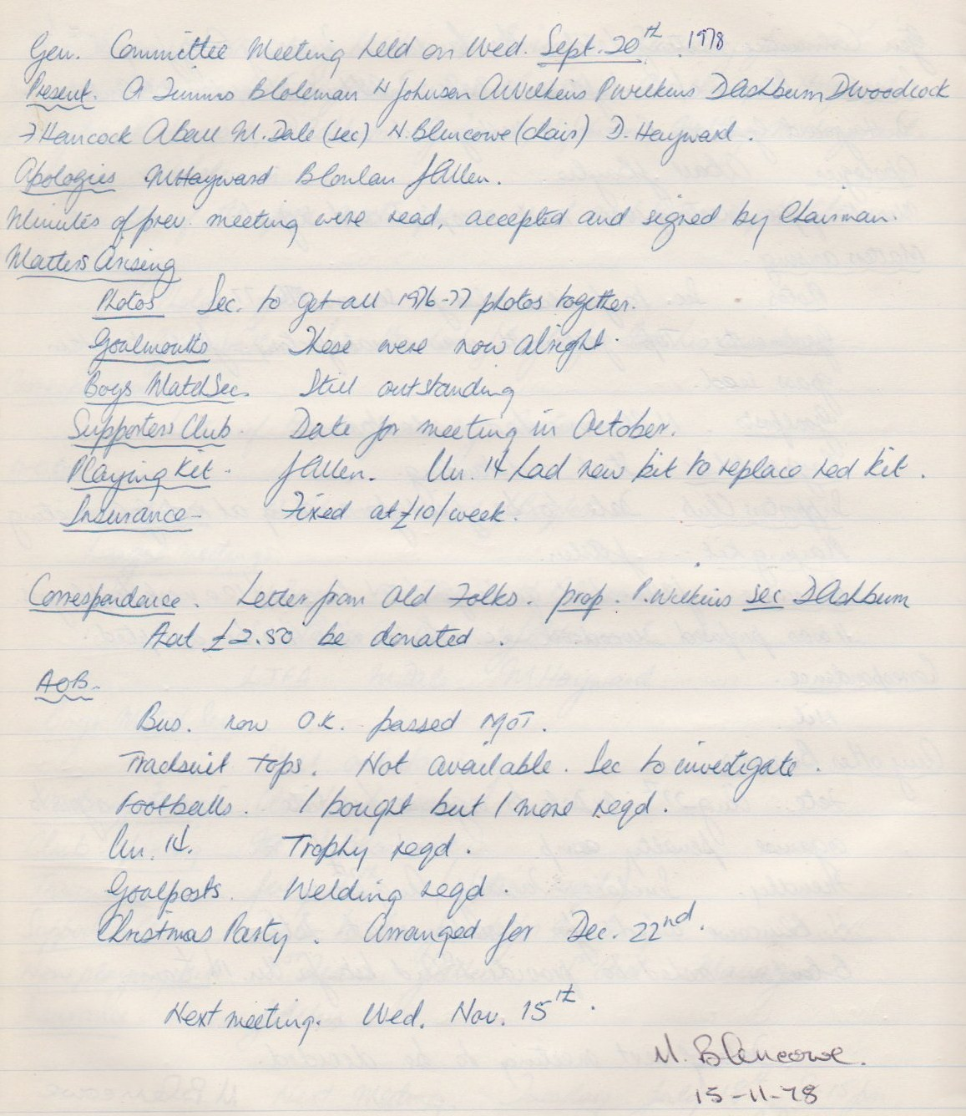

**General Committee Meeting**

**November 15th 1978**

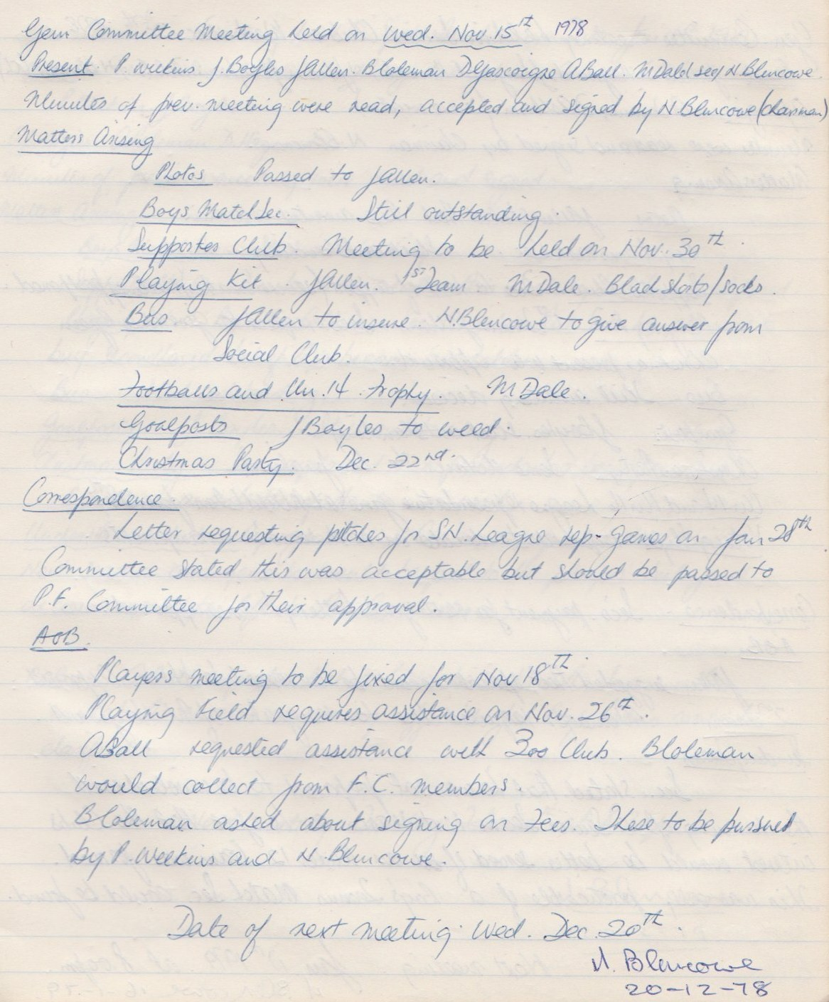

**General Committee Meeting**

**December 20th 1978**

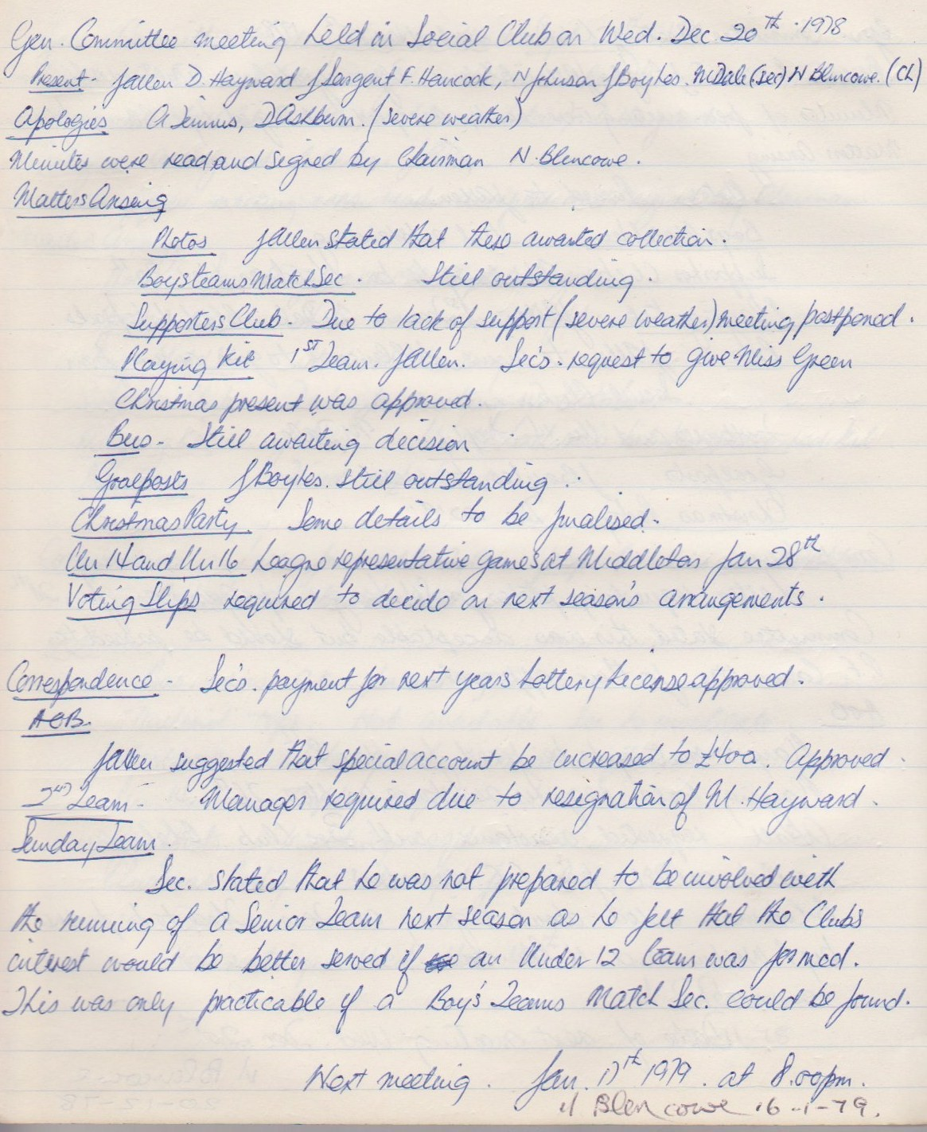

**General Committee Meeting**

**January 16th 1979**

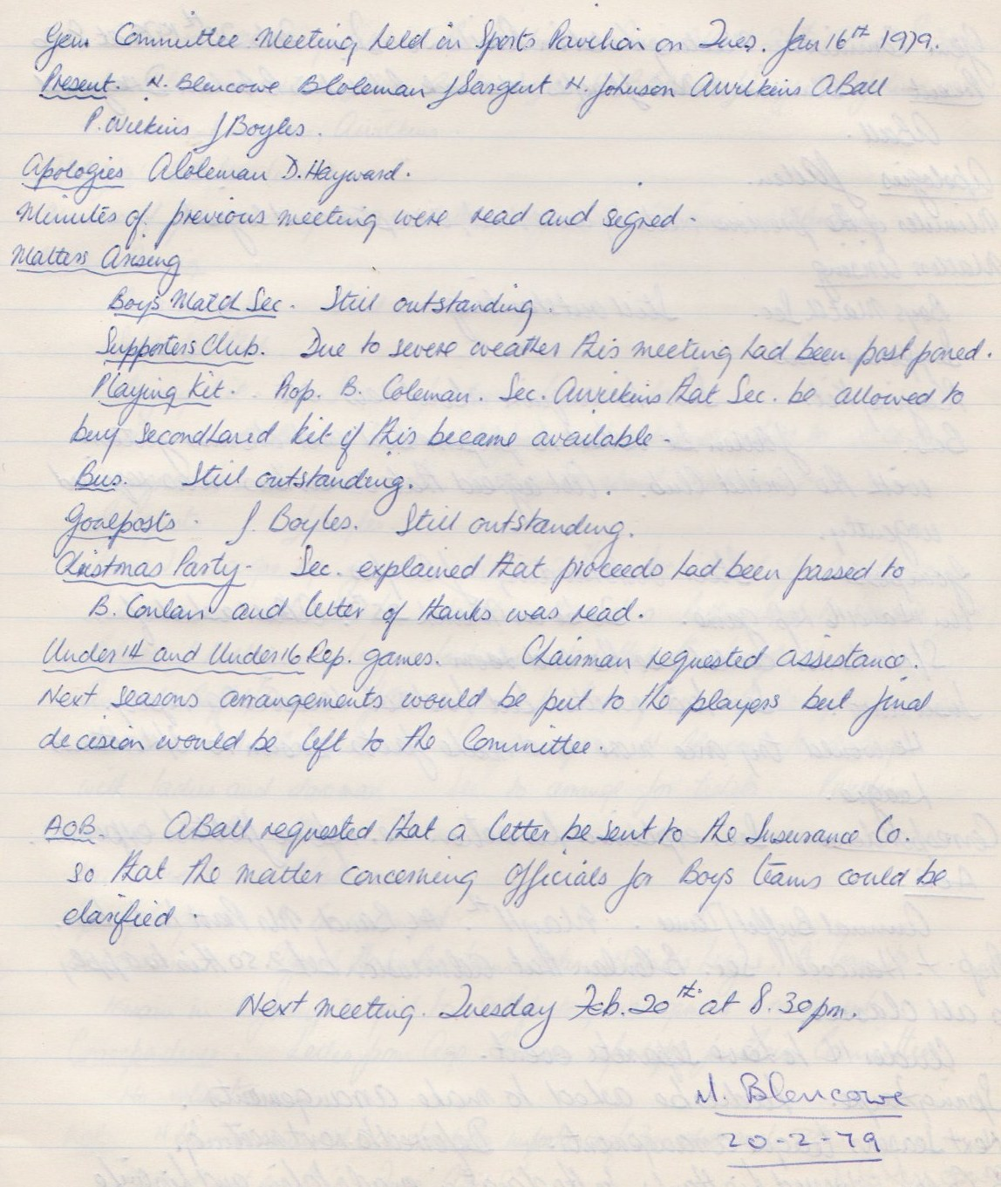

**General Committee Meeting**

**February 20th 1979**

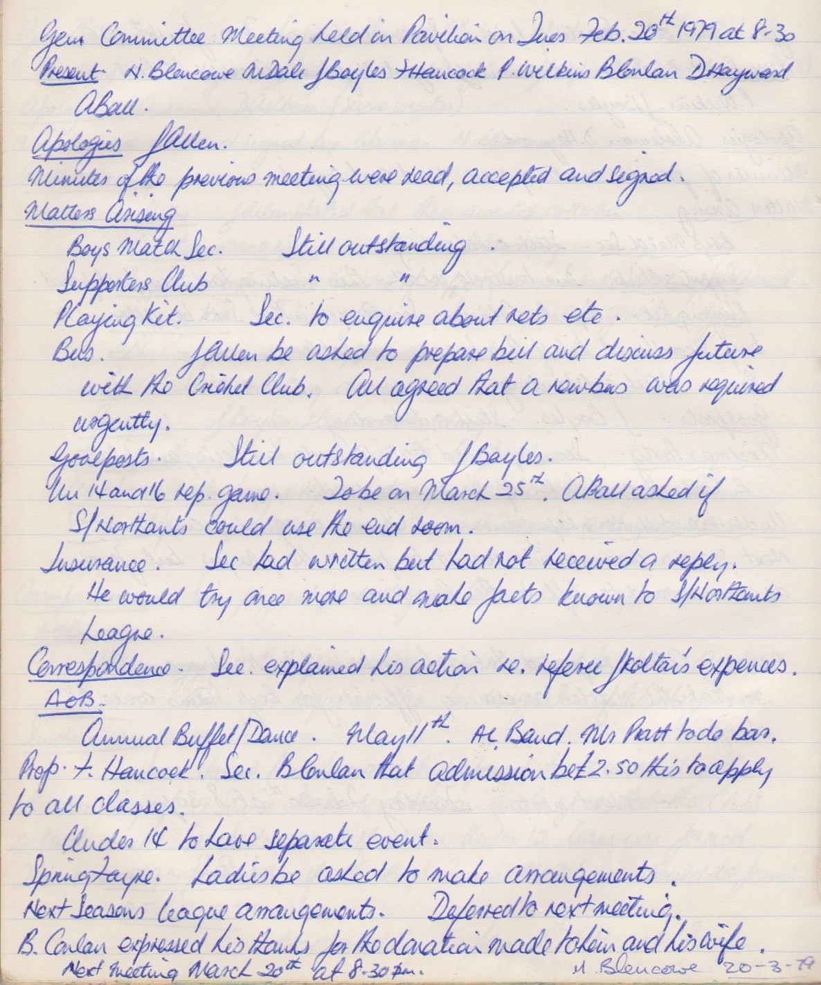

**General Committee Meeting**

**March 20th 1979**

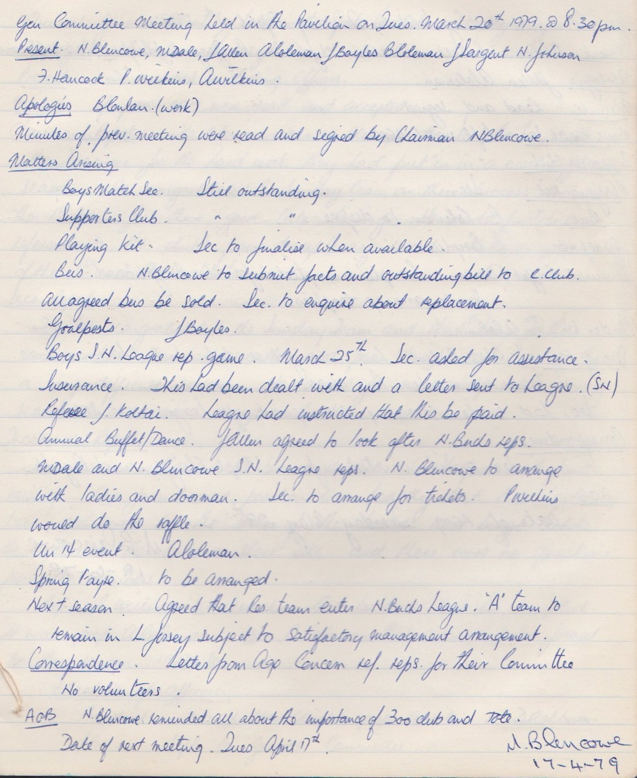

**General Committee Meeting**

**April 17th 1979**

